**Phase 8: Data Management & Deployment**

1. **Data Import Wizard**
   * App Launcher → Data Import Wizard.
   * Choose object (e.g., Donor).
   * Upload CSV file (Name, Phone, Email).
   * Run → Check if records are created.

1. **Data Loader**
   * Download Salesforce Data Loader (from Setup).
   * Login → Insert 100+ test records using CSV.
   * Try Export & Delete also.

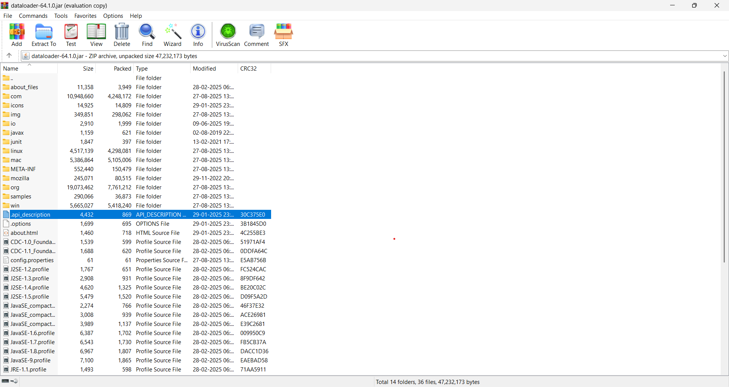

1. **Duplicate Rules**
   * Setup → Duplicate Rules → New Rule (on Donor).
   * Match by Email.
   * Activate → Try creating same email donor twice → error shows.

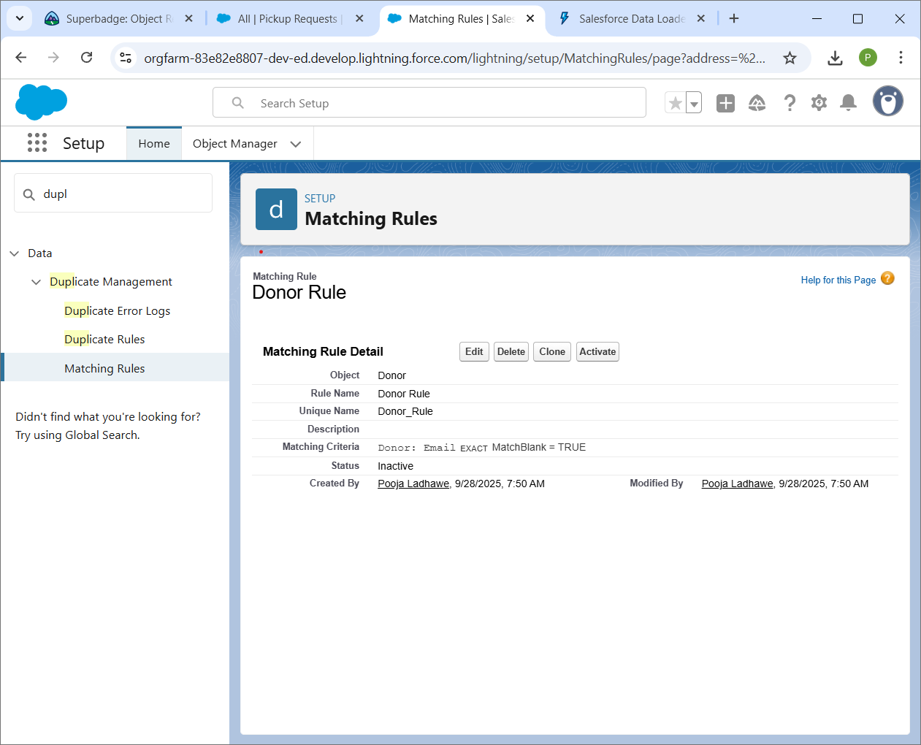

1. **Data Export & Backup**
   * Setup → Data Export → Schedule Weekly Export.

